Web Application Security Assessment Report

Executive Summary
This assessment evaluated the security posture of a vulnerable web application environment. Multiple high-risk vulnerabilities were identified, including SQL Injection and weak authentication mechanisms. These issues could allow attackers to gain unauthorized access, extract sensitive data, and compromise system integrity. Immediate remediation is recommended to reduce risk exposure and strengthen overall security.

Attack Path Diagram
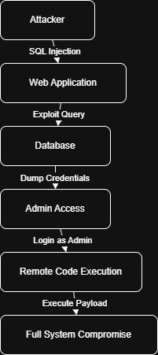

Technical Findings
1. SQL Injection: Improper input validation allows attackers to manipulate database queries.
2. Cross-Site Scripting (XSS): Unsanitized user input enables script execution in user browsers.
3. Weak Authentication: Use of default or weak credentials increases risk of unauthorized access.
4. Security Misconfiguration: Exposed services and unnecessary ports increase attack surface.

Remediation Plan
- Implement strict input validation and parameterized queries.
- Enforce strong password policies and multi-factor authentication.
- Regularly update and patch all systems.
- Disable unused services and secure configurations.
- Implement proper logging and monitoring mechanisms.

Findings Table
Finding ID | Vulnerability | CVSS Score | Remediation
F001 | SQL Injection | 9.1 | Input validation & parameterized queries
F002 | Weak Password | 7.5 | Enforce password complexity

Management Brief (Non-Technical Summary)
This security assessment identified several critical weaknesses in the system that could allow attackers to gain unauthorized access and control. The most serious issue involves improper handling of user input, which could expose sensitive data. We also found weak password protections that make it easier for attackers to break into accounts. If exploited, these vulnerabilities could lead to data breaches, service disruption, and reputational damage. It is important to fix these issues quickly by improving input validation, strengthening password rules, and updating outdated systems. Taking these actions will significantly reduce the risk and improve overall security.

